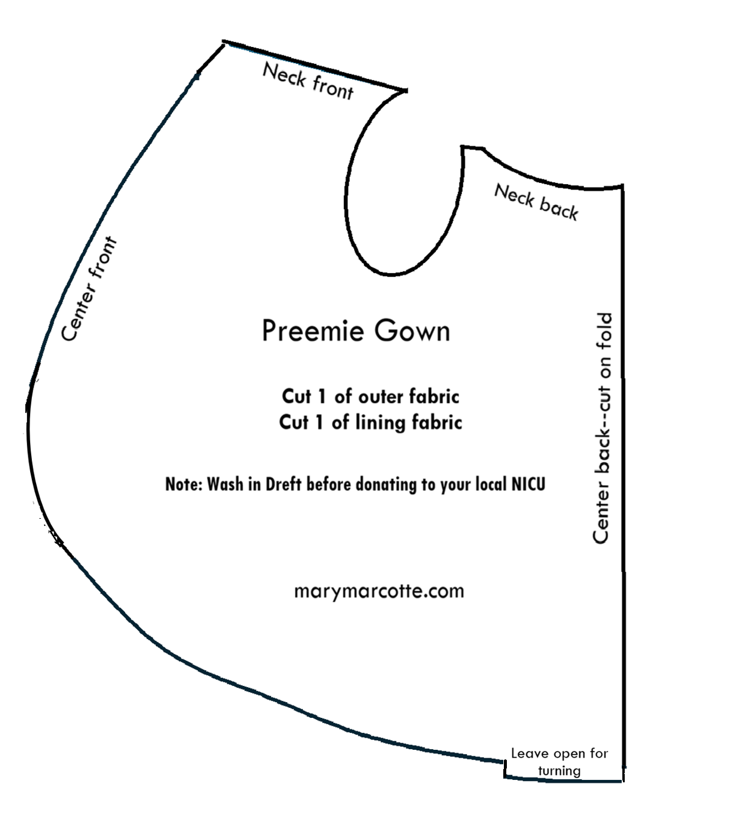
Join a global community of volunteers creating tiny gowns for babies in the NICU. This simple, NICU-approved pattern is widely accepted and can be sewn quickly using soft, baby-friendly fabrics.
Each gown is a meaningful gift to families facing one of the most difficult times in their lives. Seeing their baby dressed for the first time often brings comfort, joy, and renewed hope. Your donation of time and talent helps families celebrate a precious milestone while their little one continues to fight and grow stronger.
NICU Gown Sewing Instructions
Supplies
- Printed pattern
- 2 sheets: 8½ X 11 printer paper or cardstock paper
- 1 piece of 18 X 12 fabric that softens as it is washed (quilting cottons and baby-themed cottons work well for the outside fabric)
- 1 piece of 18 X 12 fabric that softens as it is washed (muslin, thin cottons, and baby-themed cottons work well for the lining fabric)
- 4 small snaps or 2 pieces of 1½ inches of Velcro
- Sewing machine
- Turning tool, scissors, pins or clips, paper scissors
- Iron

- Prepare the pattern
  - Print pattern onto printer paper or cardstock
  - Tape the two sheets of paper together on the long edge
  - Fold the paper in half along the taped edges with the printed side out
  - Cut both sheets out following the outside black line of printed pattern
  - Open at the fold for a full-size pattern

- Cut out fabric
  - With fabrics right sides together (RST) press well
  - Place pattern down and pin or clip
  - Cut around the pattern, noting where the opening begins and ends and follow line to increase turning fold

- Sew the gown around the perimeter, beginning at the opening mark and ending at the opposite opening mark. Cut the turning fold along the line.

- Turn the gown right side out, making sure to push out all tucks and folds, especially around armseye and neck area.

- Press the turning fold in so that it meets the sewn edges. The extra fabric to makes this easier and holds up longer.

- Topstitch around the perimeter beginning and ending in the same place, Make four or five extra stitches on top of the first stitches to lock the seam in place

- Close the gown to determine where Velcro or snaps go.
  - Neck front and back overlap and require two snaps in the corners (be careful to match the snaps so they meet without twisting the armhole.
  - Velcro, the arms require one piece about one inch long
  - Center front pieces overlap near the top and require two snaps. Or one and a helf inch of Velcro. Leave a one or one and a half inch gap from top edge if you think the neck is too tight.

- Wash with Dreft laundry detergent before donating.

Thank you for your kind donation to our smallest babies!

